SOP for Federated EGA Helpdesk - Add new Helpdesk officers to your Helpdesk Portal

Document Owner | Aina Jené - EGA-CRG Operations Manager
Version | 1.0
Effective date | 31-05-2023

Purpose
Once you have set up your FEGA Helpdesk Portal, you can manage who accesses your Helpdesk portal from now on. If you don’t know how to get access to your FEGA Helpdesk node for the first time, please follow this SOP.

Scope
This SOP indicates the steps to follow in order to add new Helpdesk officers as admin for your FEGA Helpdesk Portal.

Procedure
- The new member to be added to your FEGA Helpdesk Portal needs to register as an EGA user by populating the registration form.
- CEGA Helpdesk will have to verify your account. Once it has been verified by CEGA Helpdesk you can proceed with step 3.
- A FEGA Helpdesk admin will login to their FEGA Helpdesk Portal (helpdesk.{fega}.ega.archive.org) ans go to ROLES
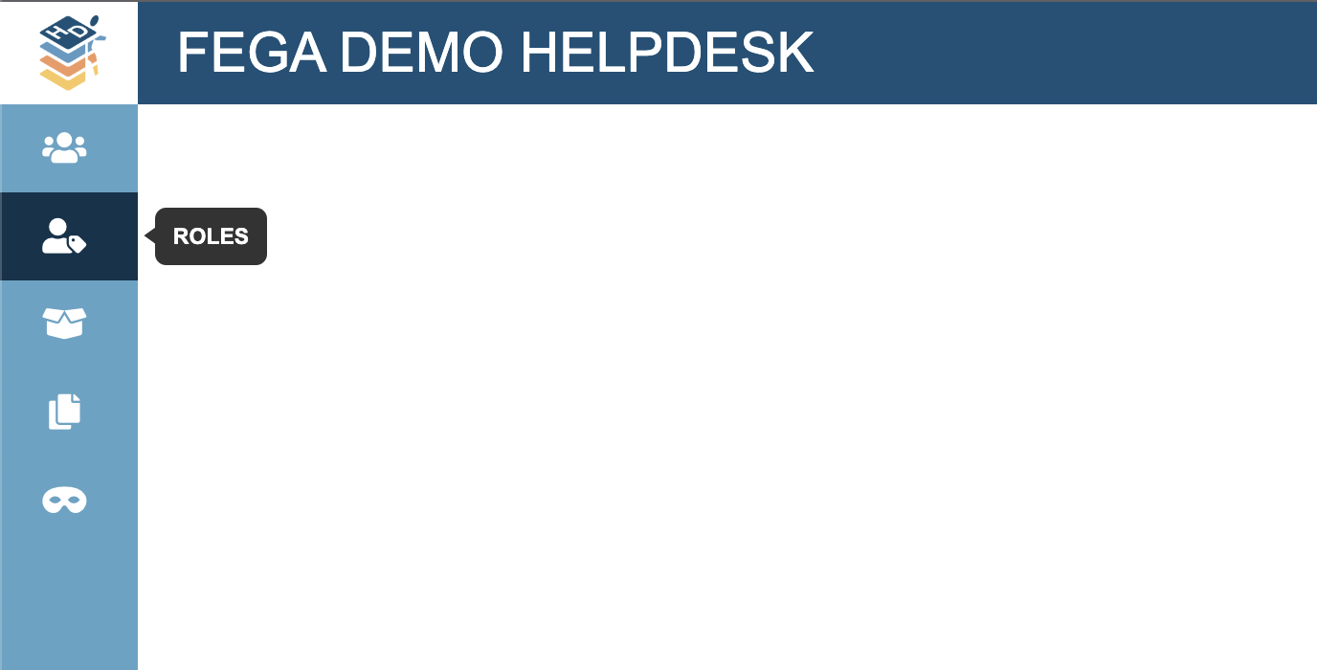
- Look for the member registered in step 1
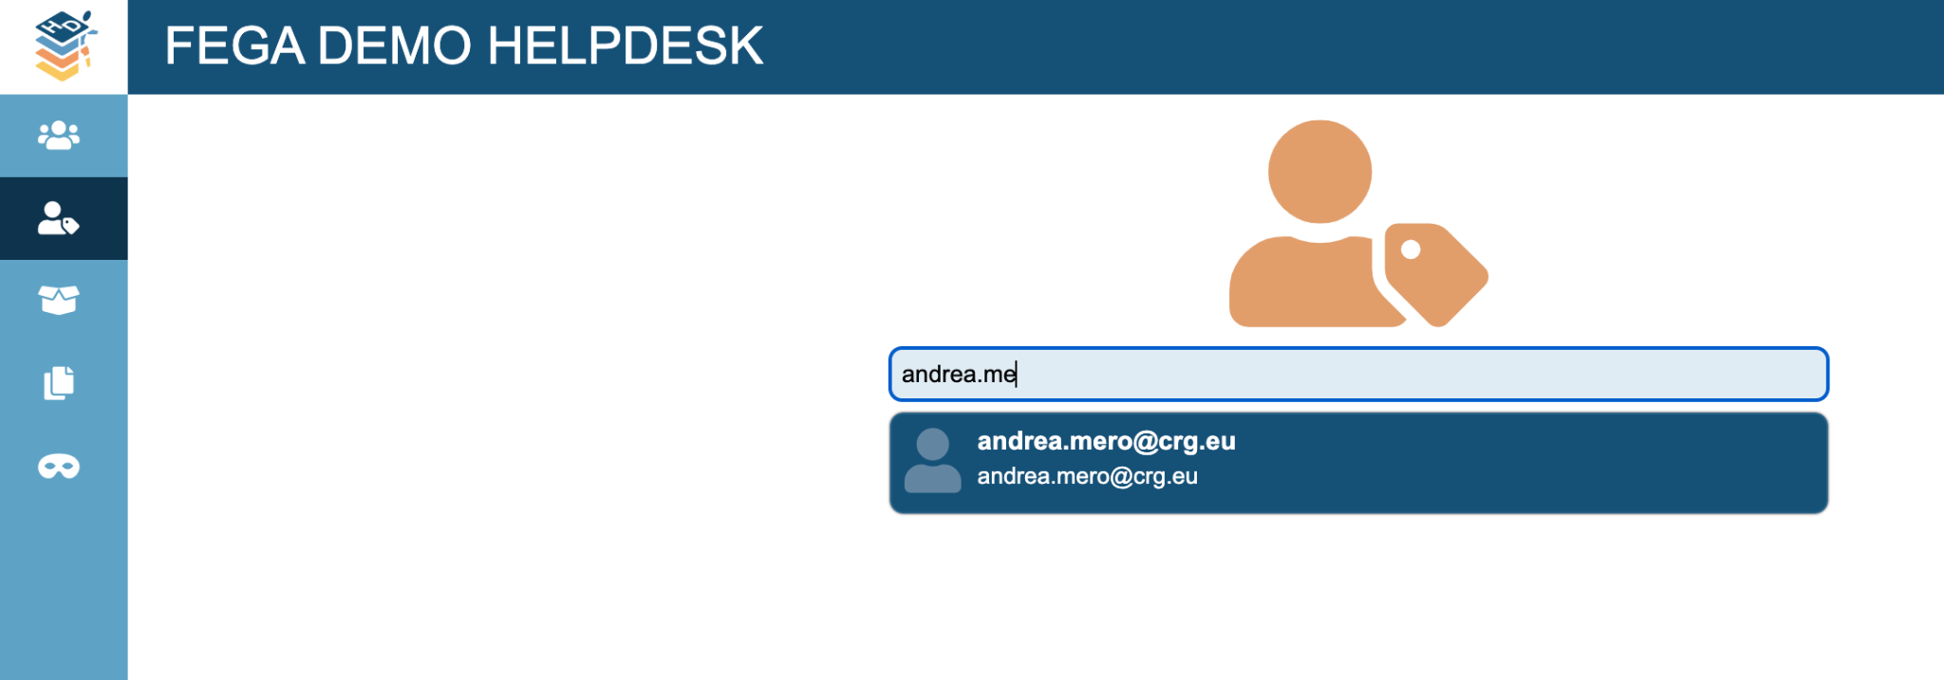
- Click on the role you want to grant to this user ({fega} helpdesk) and click on UPDATE ROLES
